Date access: 2020-03-09

<http://wjw.beijing.gov.cn/wjwh/ztzl/xxgzbd/gzbdyqtb/202001/t20200130_1621748.html>

From 12:00 to 20:00 on January 29, 9 new cases of pneumonia infected with new coronavirus were added in this city

Date: 2020-01-29 Source: Beijing Municipal Commission of Health

        From 12:00 to 20:00 on January 29, 9 new cases of pneumonia infected with new coronavirus were added to the city, 7 of which had contact history in Hubei and other provinces, and 2 were close contacts of confirmed cases, all of which have been sent to the city Level designated medical institutions for treatment.

As of 20:00 on January 29, the city has accumulated a total of 111 confirmed cases, of which 4 were discharged and 1 died. The 106 confirmed cases under treatment were all isolated and treated at city-level designated hospitals, 90 in general and 14 in severe cases. Critical 2 cases. 2 cases in Dongcheng District, 12 cases in Xicheng District, 21 cases in Chaoyang District, 24 cases in Haidian District, 10 cases in Fengtai District, 2 cases in Shijingshan District, 1 case in Mentougou District, 8 cases in Tongzhou District, 2 cases in Shunyi District, 10 cases in Daxing District, There were 8 cases in Changping District, and 11 cases came from overseas. No cases have been found in Fangshan District, Pinggu District, Huairou District, Miyun District, and Yanqing District.

**1月29日12时至20时，本市新增9例新型冠状病毒感染的肺炎病例**

日期：2020-01-29 来源：北京市卫生健康委‍

        1月29日12时至20时，本市新增9例新型冠状病毒感染的肺炎病例，其中7例有湖北及其他省份接触史，2例为确诊病例的密切接触者，均已送至市级定点医疗机构进行救治。

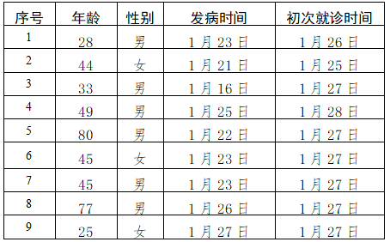

        截至1月29日20时，本市累计确诊病例111例，其中出院4例，死亡1例，在治106例确诊病例均在市级定点医院进行隔离治疗，普通型90例，重型14例，危重型2例。东城区2例、西城区12例、朝阳区21例、海淀区24例、丰台区10例、石景山区2例、门头沟区1例、通州区8例、顺义区2例、大兴区10例、昌平区8例，外地来京人员11例。房山区、平谷区、怀柔区、密云区、延庆区尚未发现病例。